Azure Virtual machine Backup process and steps

Recovery service vaults --> Select subscription and Recovery vault -- > backup items ---> SQL in Azure VM --> copy server --> select DB --> Backup now

Example DB server list:

Host Name                         Change Number            DT Start

wd2cppadbp009             CHG0134829    10-06-2023 08:30AM

wd2cppaappp007           CHG0134829     10-06-2023 08:30AM

wd2cppaappp008           CHG0134829     10-06-2023 08:30AM

Step1:

Login to portal

Select virtual machine

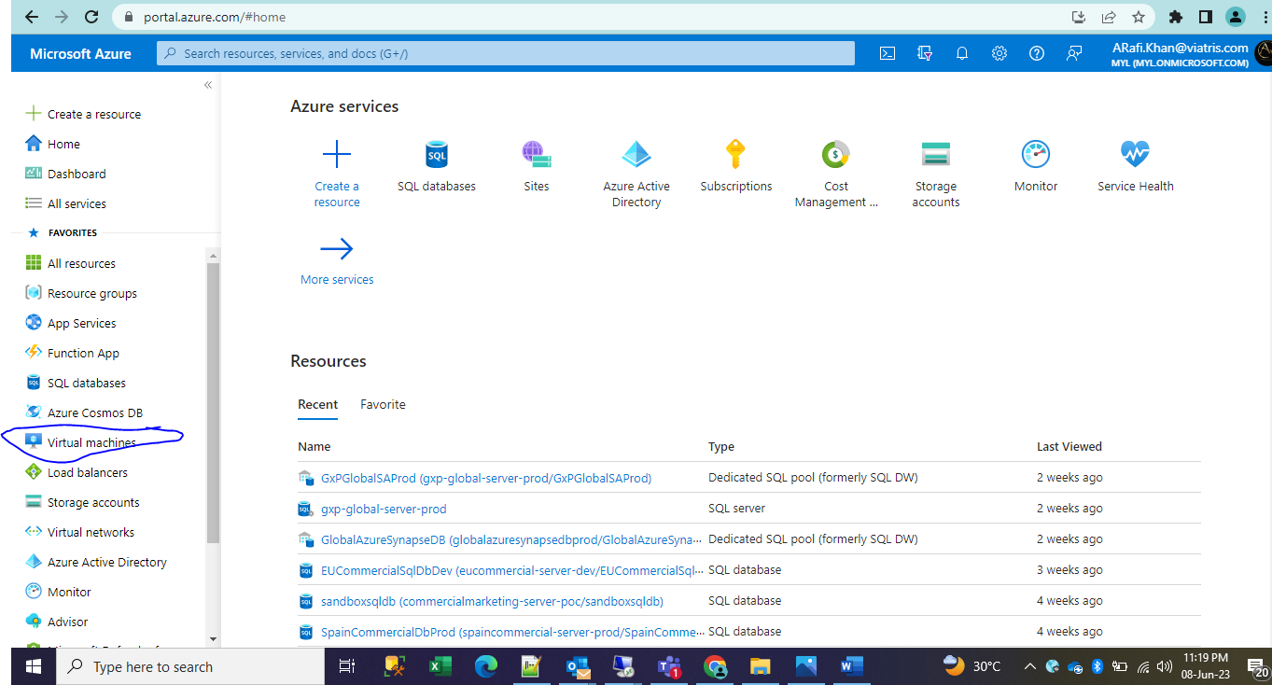

Search and open server

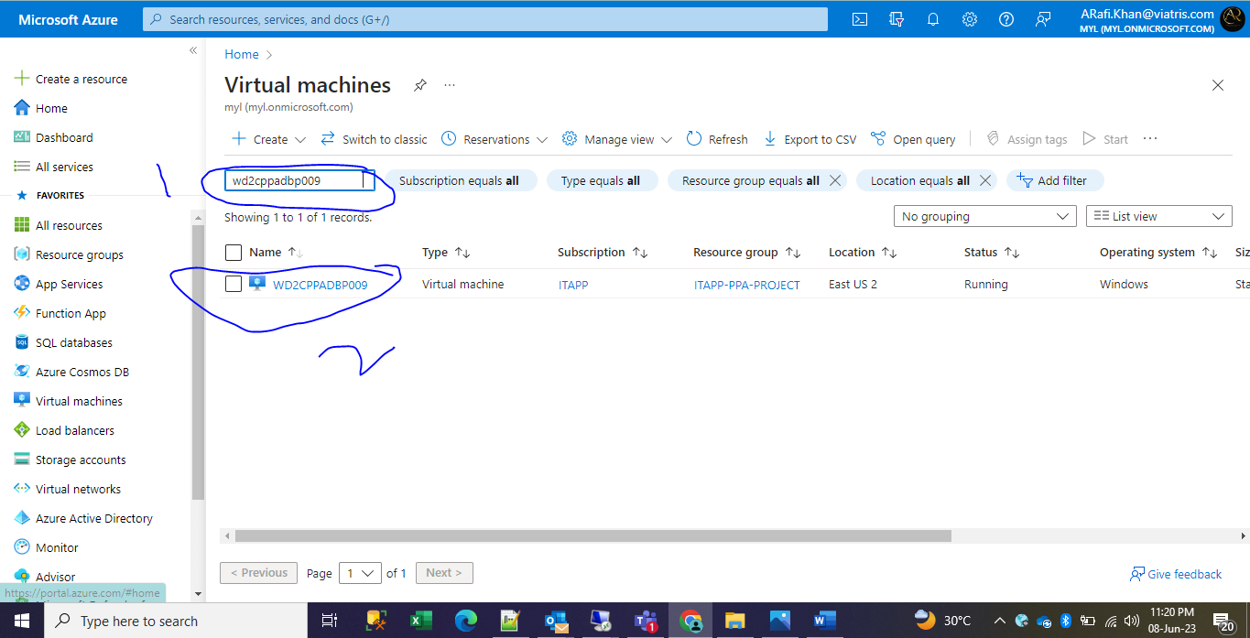

Note down the Subscription and open the backup left side

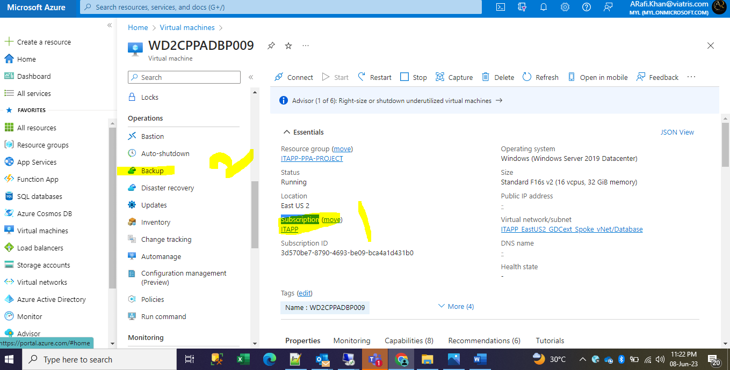

Note down the Recovery services vault

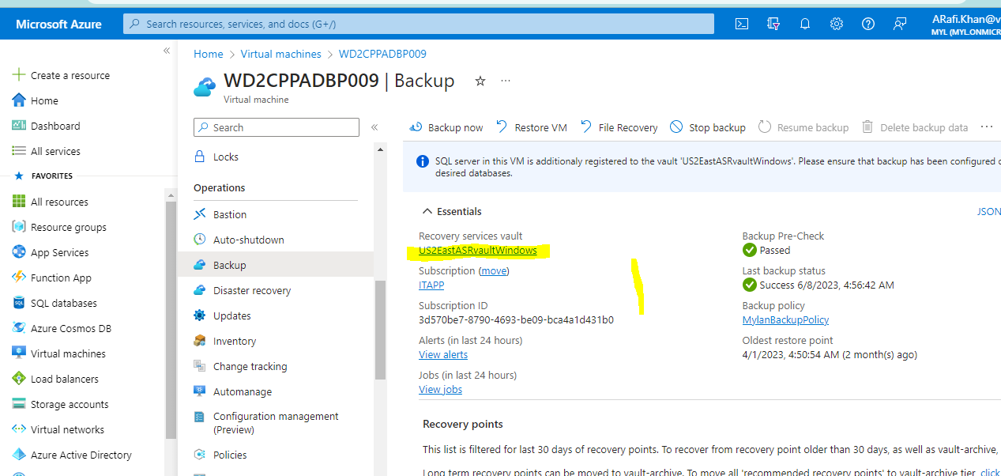

Now go to home

Search for Recovery service vaults

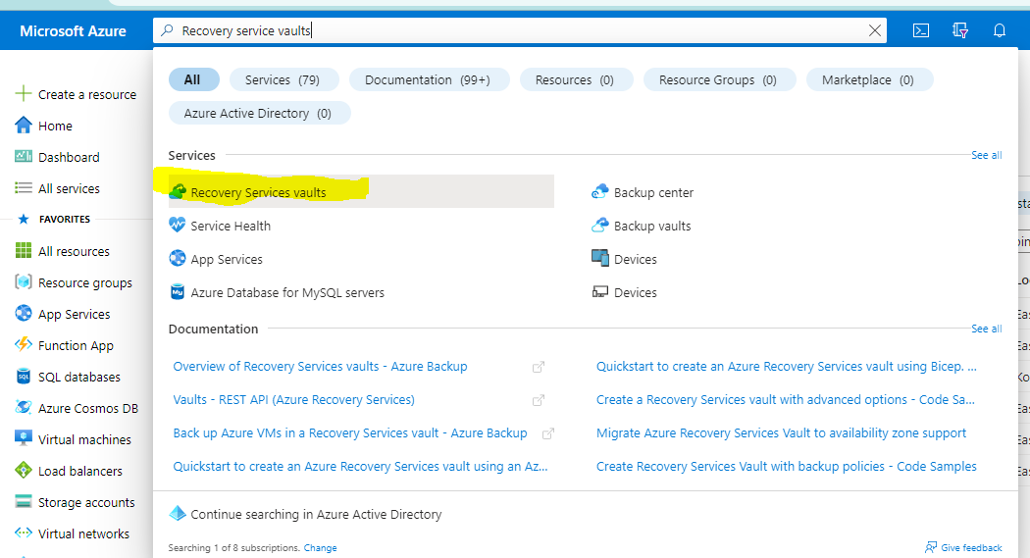

Select the subscription type 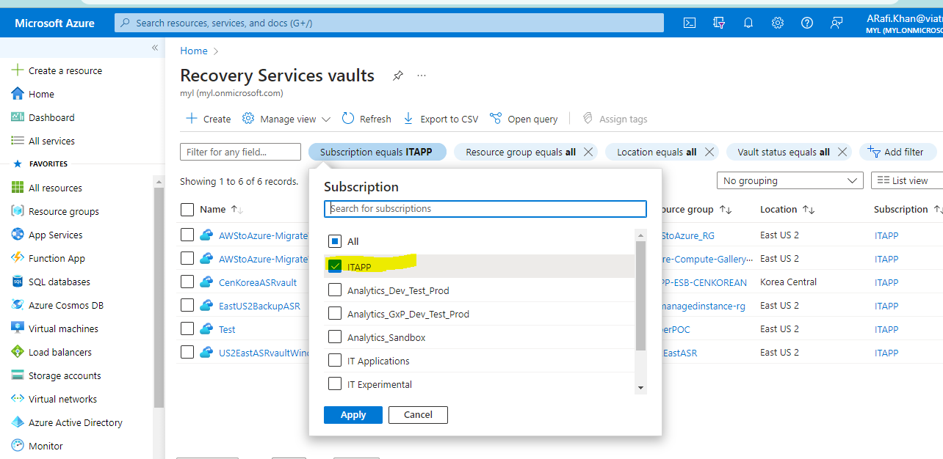

Select the recovery vault name which is noted above in VM

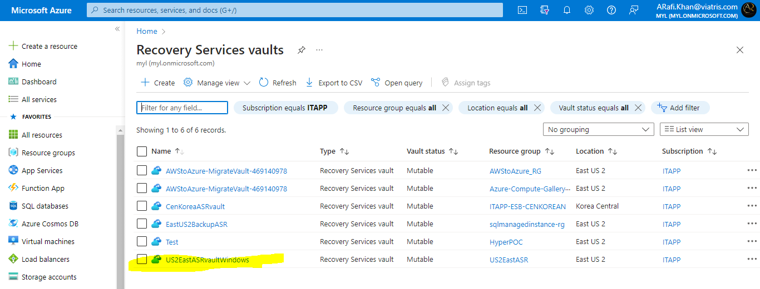

Select the Backup item

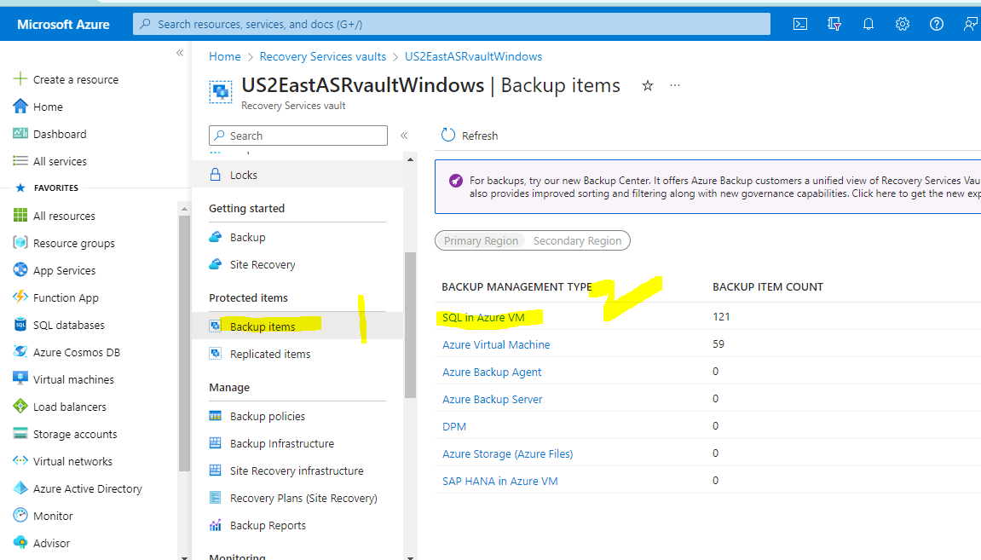

Under SQL azure Vm

Search with VM server name **wd2cppadbp009**

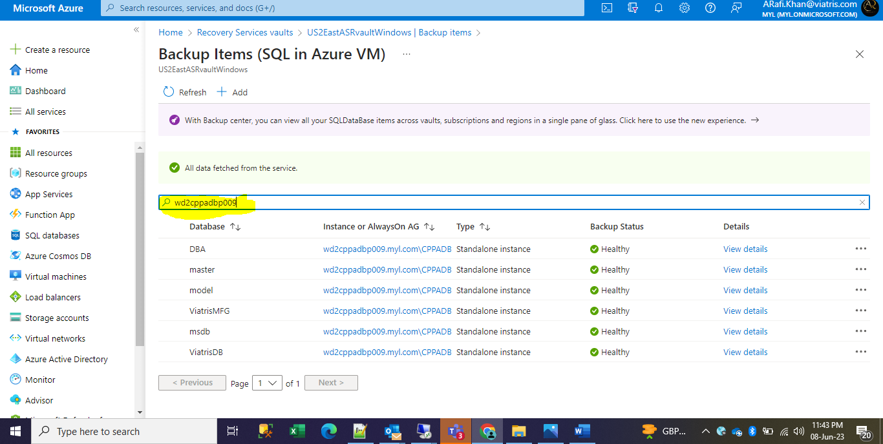

Select the database which need you backup file

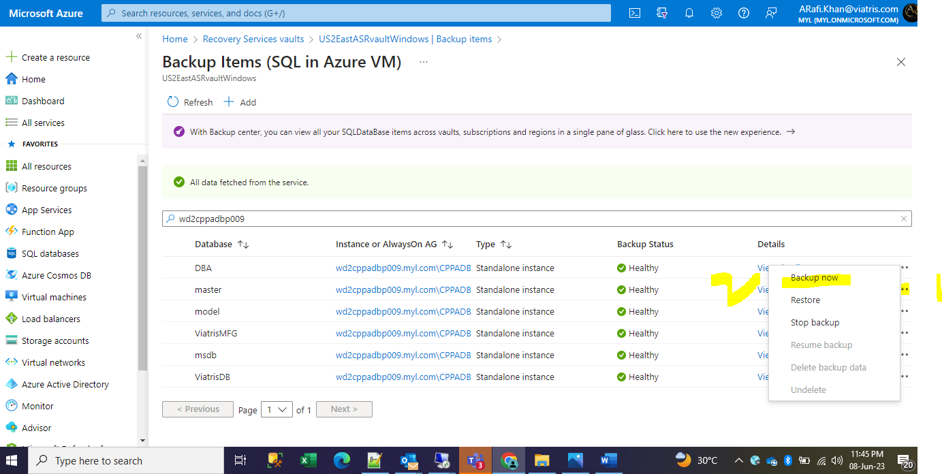

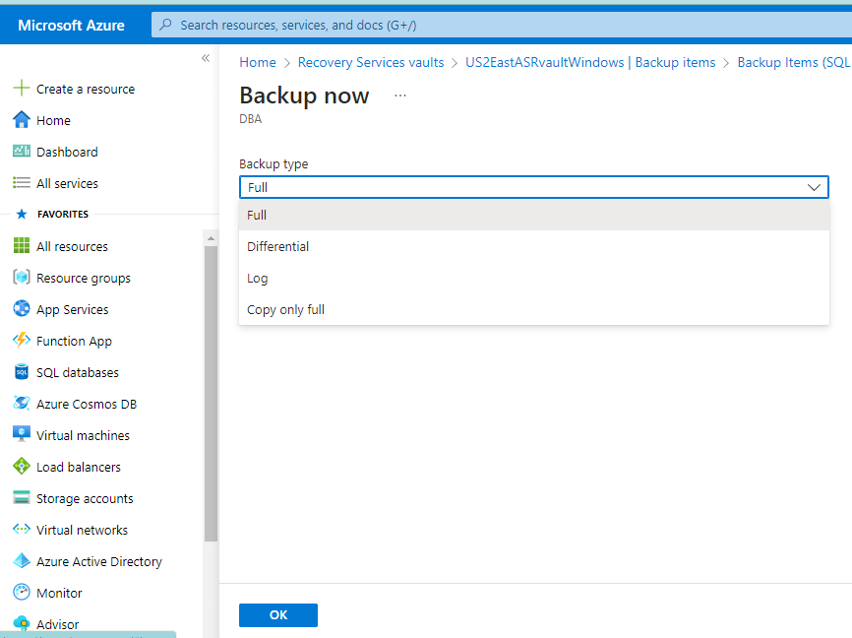

Just click ok backup will done.